MODULE 7 & 8
Q1. Try Test-Connection and nslookup commands for below websites
www.google.com www.facebook.com www.amazon.com www.github.com www.cisco.com
Test-Connection: This command checks if a website is reachable.
nslookup: This retrieves the IP address of the domain,i.e., finds the ip address of the website.
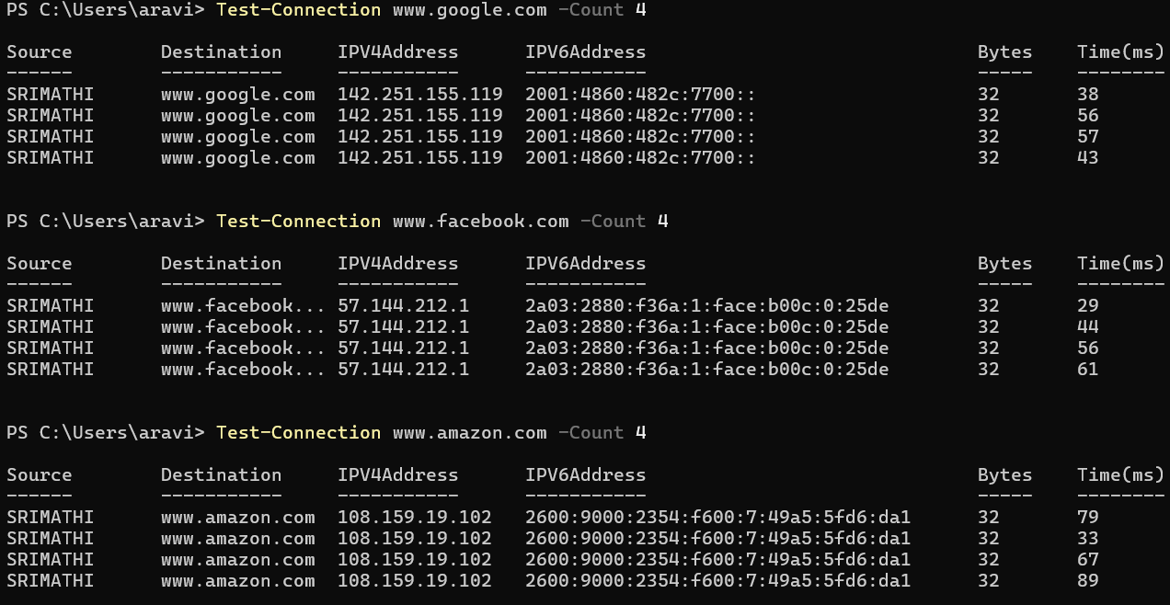
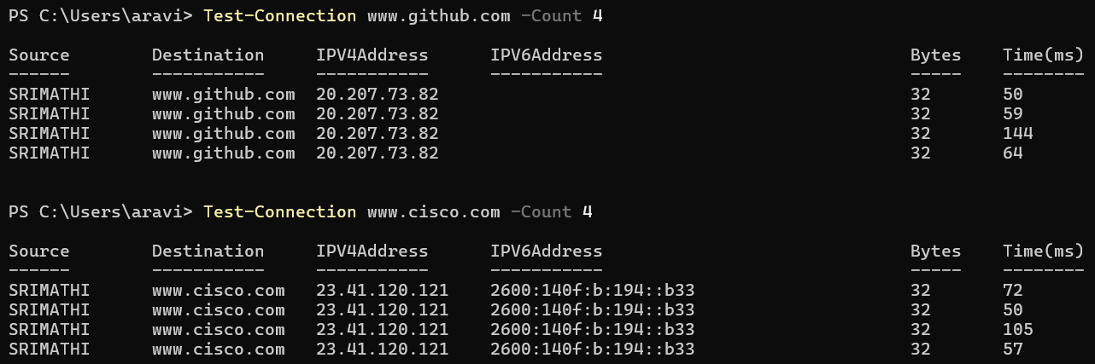

Q2. Use Wireshark to capture and analyze DNS, TCP, UDP traffic and packet header, packet flow, options and flags
DNS protocol:
- The Domain Name System (DNS) protocol is a network protocol that translates domain names into IP addresses.
- To capture DNS packets, I searched www.google.com
- As a Response it Shows the IP address for www.google.com.
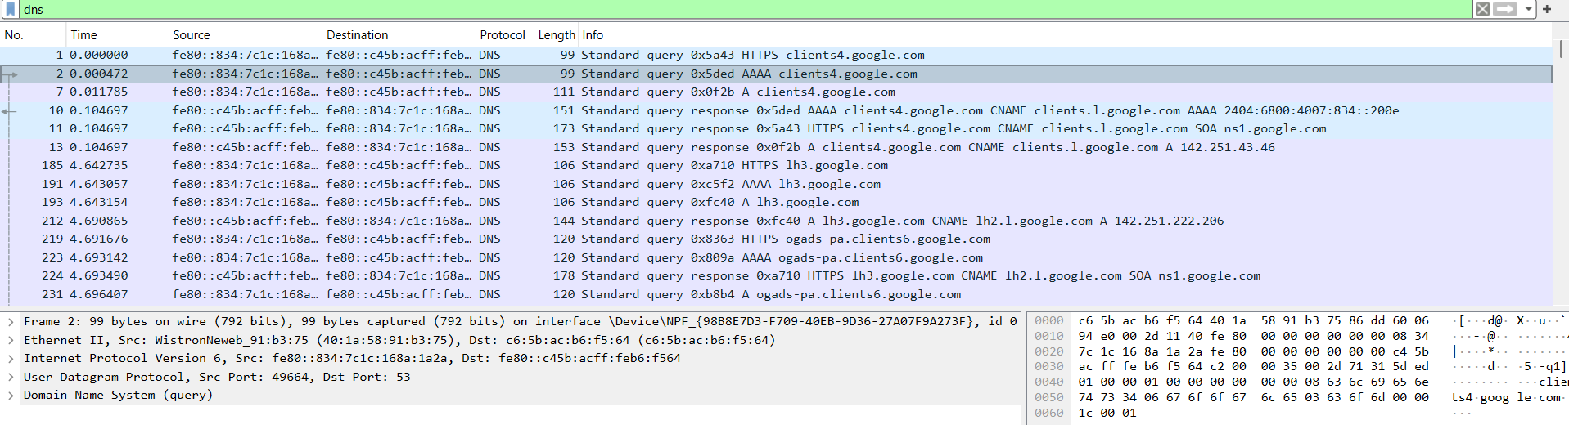
TCP:
- Transmission Control Protocol is a connection-oriented protocol for communications that helps in the exchange of messages between different devices over a network.
- TCP establishes a reliable connection between sender and receiver using the three-way handshake (SYN, SYN-ACK, ACK) and it uses a four-step handshake (FIN, ACK, FIN, ACK) to close connections properly.

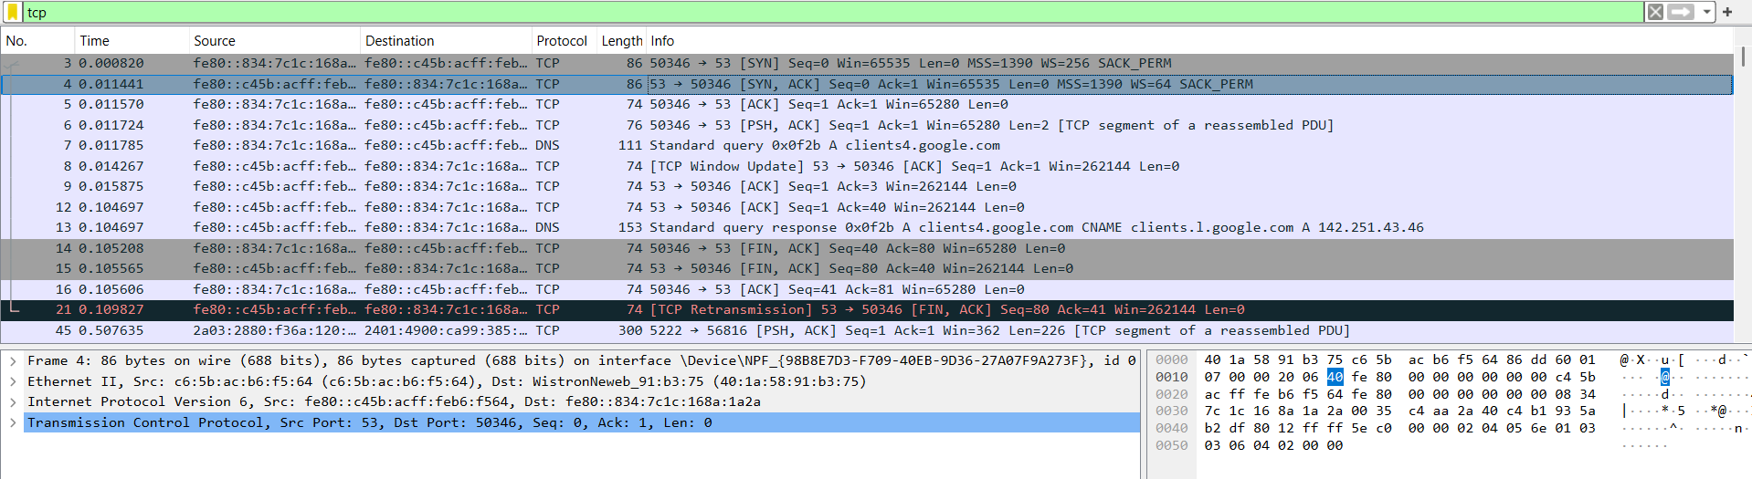
UDP:
- User Datagram Protocol is a connectionless and light-weight protocol and thus it is unreliable.
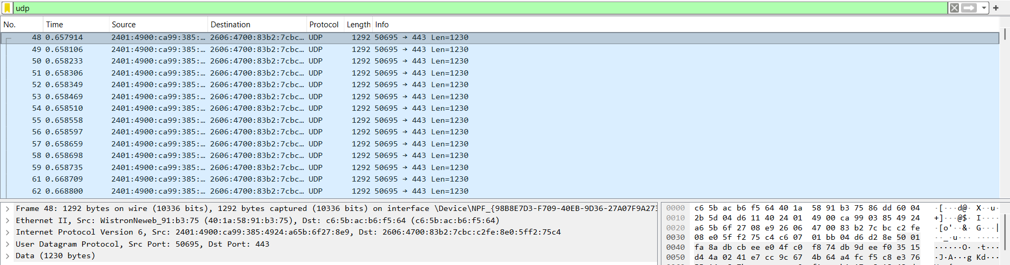

Q3. Explore traceroute/tracert for different websites eg:google.com and analyse the parameters in the output and explore different options for traceroute command

Traceroute :
- tracert is the windows version which is a network diagnostic tool used to trace the path packets take from your device to a destination (e.g., google.com). They help identify routing issues and checks whether the packet has reached the destination address.
- It provides a detailed path taken by the packets from the source device to the destination, showing each intermediate router or "hop" along the way.

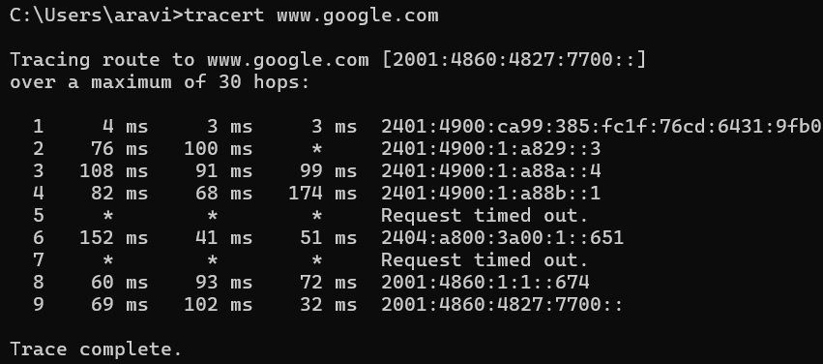

There are various versions of tracert which are as follows:
- tracert www.google.com : Basic syntax to run tracert to a specified destination (IP address or domain name).
- tracert -h 20 www.google.com : Sets the maximum number of hops to trace before terminating.
- tracert -w 1000 www.google.com : Specifies the timeout in milliseconds to wait for each reply. Default is 4000 ms.
- tracert -4 www.google.com : Forces tracert to use IPv4 for the trace.
- tracert -6 www.google.com : Forces tracert to use IPv6 for the trace.
- tracert -R www.google.com : This option routes each hop in reverse, from destination back to the source.
4. Use Cisco packet tracer for the below
Q5. Set up trunk ports between switches and try ping between different VLANS.

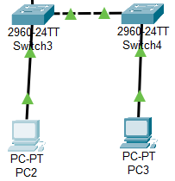

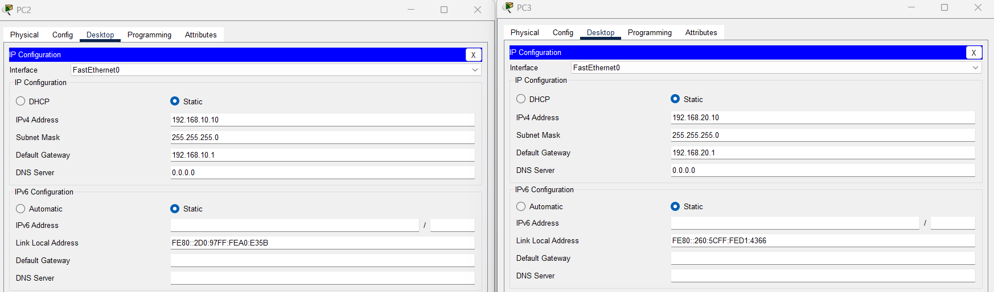

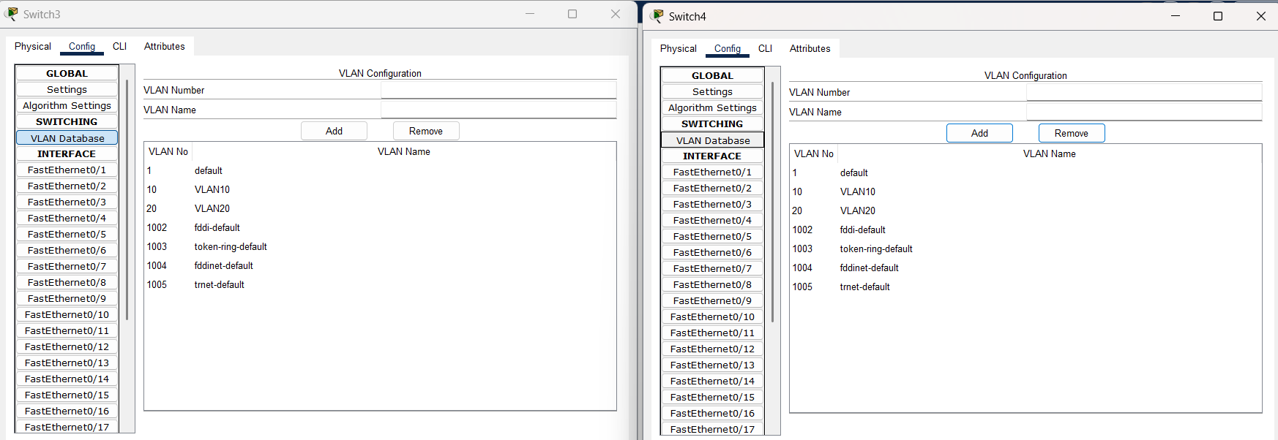

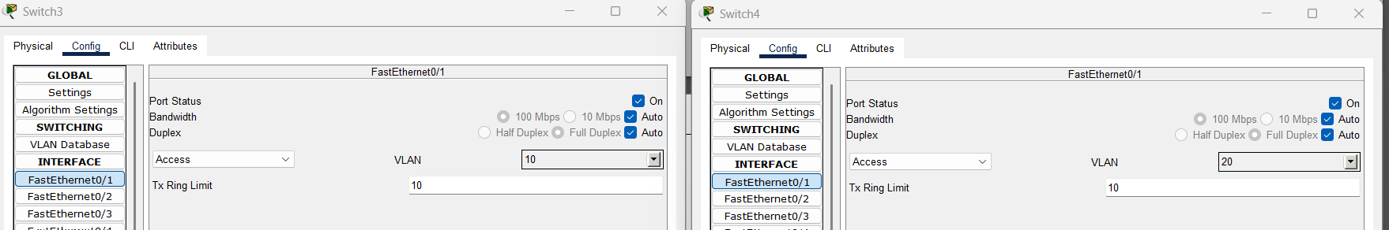

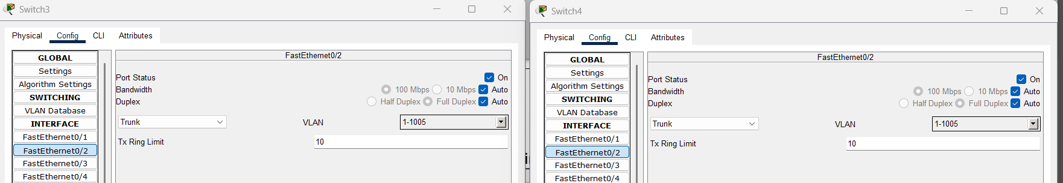

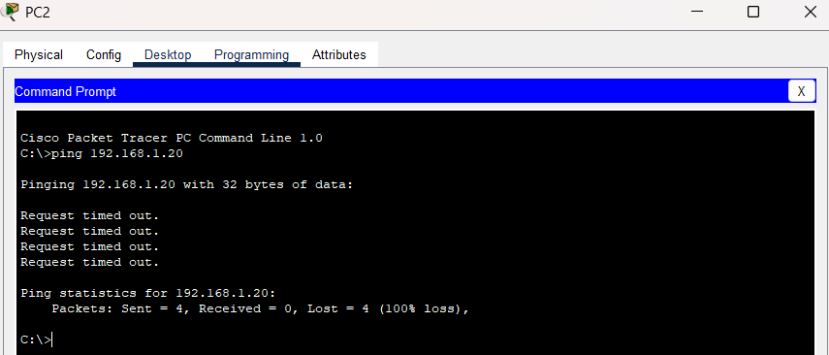

Ping between different VLANs failed because VLANs are isolated networks. Inter-VLAN routing is required for communication.

Q6. Change the native VLAN on a trunk port. Test for VLAN mismatches and
troubleshoot.
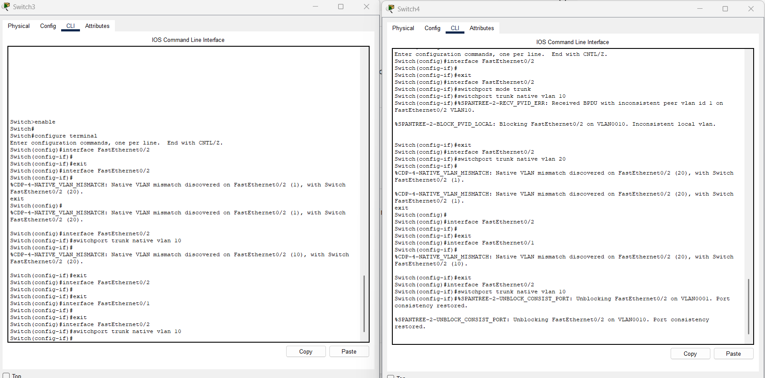
Switch 3:
enable
conf t
interface fa0/2
switchport mode trunk
switchport trunk native vlan 10

Switch 4:
enable
conf t
interface fa0/2
switchport mode trunk
switchport trunk native vlan 10

Setting the same native VLAN fixes trunk mismatch, but ping between different VLANs will still not work because inter-VLAN routing is required.

Q7. You have a Cisco switch and a VoIP phone that needs to be placed in a voice VLAN (VLAN 20). The data for the PC should remain in a separate VLAN (VLAN 10). Configure the switch port to support both voice and data traffic.

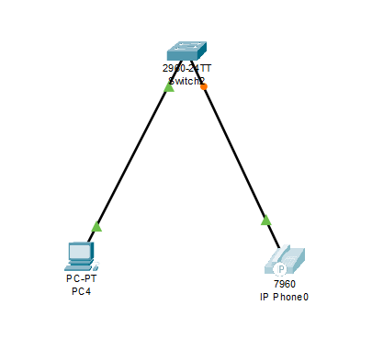
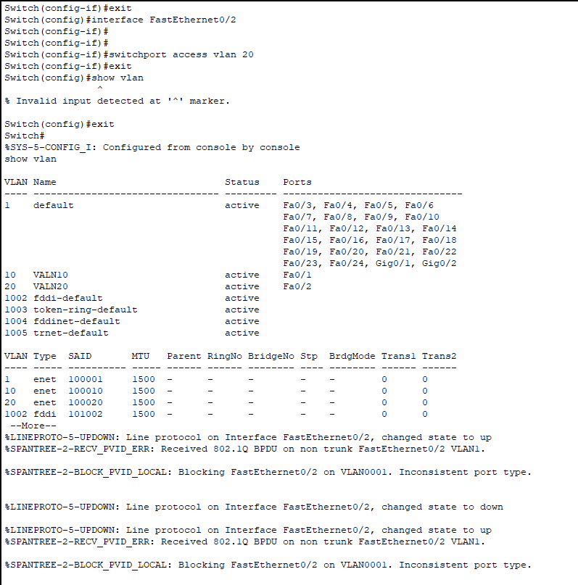

Q8. You configured VLANs 10 and 20 on your switch and assigned ports to each VLAN. However, devices in VLAN 10 cannot communicate with devices in VLAN 20. Troubleshoot the issue.
If devices in VLAN 10 cannot communicate with devices in VLAN 20, the problem is likely due to the absence of inter-VLAN routing, incorrect VLAN configurations, or trunking misconfigurations. Follow these steps to diagnose and resolve the issue:
Enable Inter-VLAN Routing
Layer 2 switches cannot perform inter-VLAN routing, so a Layer 3 device (Router-on-a-Stick or Layer 3 switch) is needed.
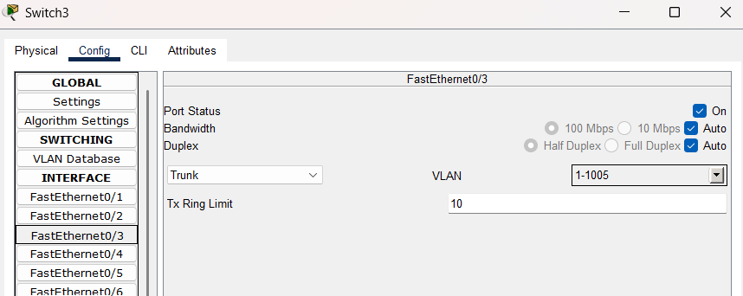

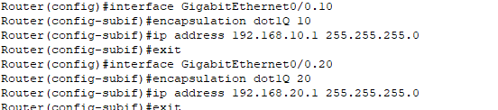

For Router-on-a-Stick (Router with Subinterfaces):
Router(config)# interface GigabitEthernet 0/0.10
Router(config-subif)# encapsulation dot1Q 10
Router(config-subif)# ip address 192.168.10.1 255.255.255.0
Router(config-subif)# exit
Router(config)# interface GigabitEthernet 0/0.20
Router(config-subif)# encapsulation dot1Q 20
Router(config-subif)# ip address 192.168.20.1 255.255.255.0
Router(config-subif)# exit

Ensure that trunking is enabled between the switch and router.

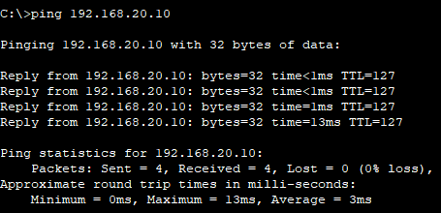

Q9. Try Inter VLAN routing with Router

- Inter-VLAN routing allows communication between different VLANs using a router.
- Since Layer 2 switches cannot route traffic between VLANs, we use a Router-on-a-Stick configuration.
Steps:
- First I have configured the switches and created VLAN10 and VLAN20.
- I connected a trunk port with the router.
- Next, I configured the router.
- I verified their connectivity using the ping command (VLAN10(PC0) to VLAN20(PC1)) and got successful replies.

Q10. Implement ACLs to restrict traffic based on source and destination ports. Test rules by simulating legitimate and unauthorized traffic.

Access Control Lists (ACLs) are used to filter network traffic based on IP addresses, protocols, and port numbers. There are 2 ways to implement Standard ACLs (Source IP-based) or Extended ACLs (IP + Port-based).
Here, I’m using an Extended ACL to restrict traffic based on source and destination ports and test it with both legitimate and unauthorized traffic.

Steps:
- Set up a network using a server,router,switch and 2 PC's.
- Configure switches and as in VLANs.
- Configure router for inter VLAN routing.
- To implement ACL:
- Now, apply an ACL to restrict PC1 from accessing the Web Server on Port 80. Router(config)# access-list 100 permit tcp host 192.168.10.10 any eq 80 Router(config)# access-list 100 deny tcp host 192.168.10.20 any eq 80 Router(config)# access-list 100 permit ip any any
here,
- PC0 (192.168.10.10) -> Allowed HTTP (Port 80) Traffic to Any Destination
- PC1 (192.168.10.20) -> Denied HTTP (Port 80) Traffic to Any Destination
- All Other Traffic is Allowed

Testing:
- From PC0, I tried accessing the Web Server on Port 80, the result was successful.
- From PC1, I tried accessing the Web Server on Port 80, host is not reachable indicating that ACL has blocked the PC1 from accessing the port 80.
- From PC1, I have checked if the ping is still working, and it provided successful replies.
- I checked the ACLs using : show access-lists

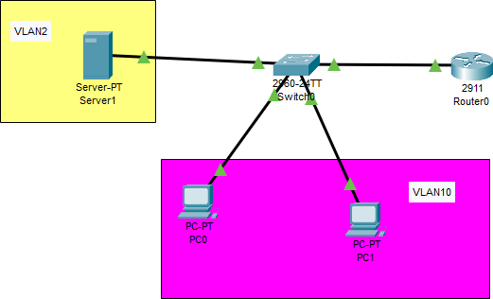
Network setup:

Switch configuration:
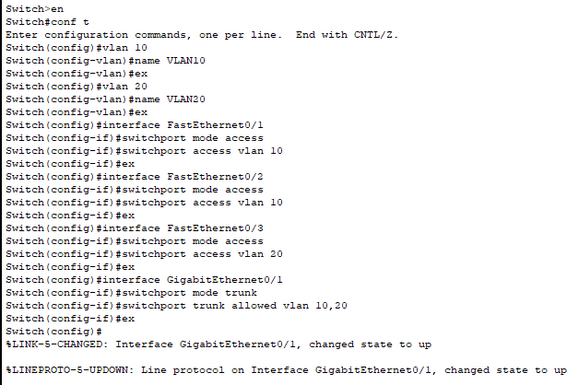

Router configuration and ACL configuration:
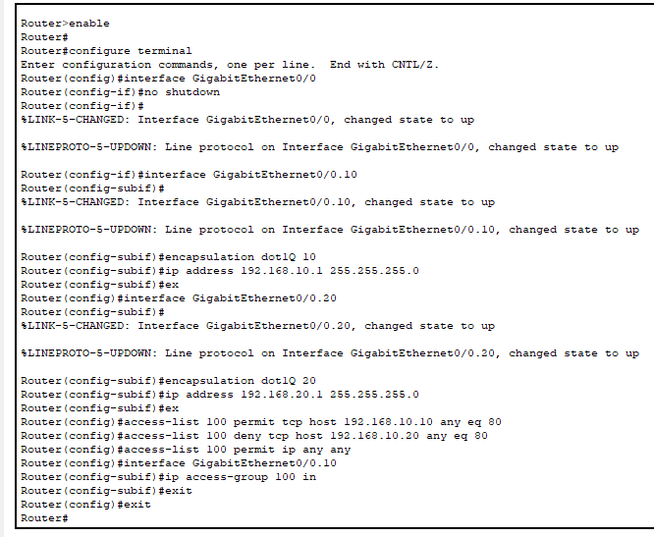

- The server is accessible from PC0:
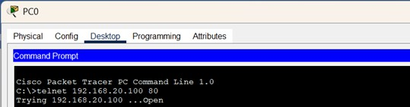

- Unable to access the server from PC1:

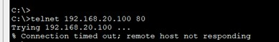

PC1 can still ping the server:
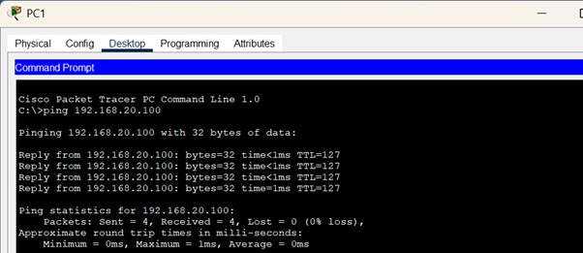

Access table:
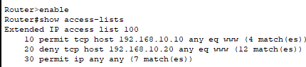

Q11. Configure a standard Access Control List (ACL) on a router to permit traffic from a specific IP range. Test connectivity to verify the ACL is working as intended.

I have set up a Standard ACL to permit traffic from a specific IP range while blocking all other traffic using the same network setup used in Question 10.
Steps:
- IP Range to Allow: 192.168.10.0/24 (all devices in VLAN 10)
- Deny All Other Traffic
- Apply ACL to the Interface for Incoming Traffic
- To achieve the router is configured with :
Router(config)# access-list 10 permit 192.168.10.0 0.0.0.255 (Allows all devices in VLAN 10 (192.168.10.x))
Router(config)# access-list 10 deny any (denies others)

Observations:
I used the ping command to check the connectivity on PC0 and PC1 and got successful replies. But i tried to use telnet and ssh on the server but it failed because we have blocked VLAN20 devices from accessing the VLAN10's service.

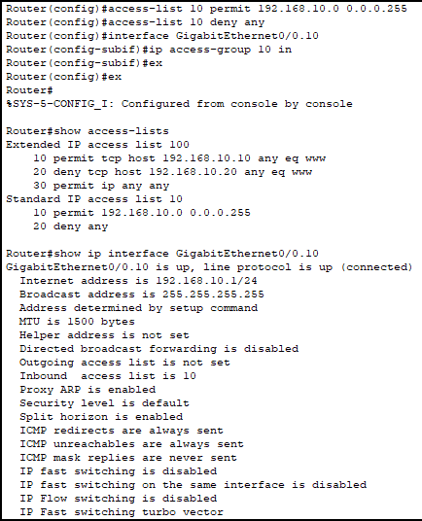
Configuring router:

To check connectivity on PC0 (192.168.10.10):
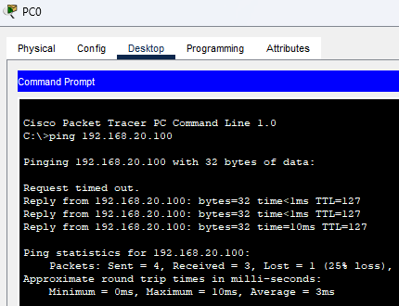

To check connectivity on PC1 (192.168.10.20):
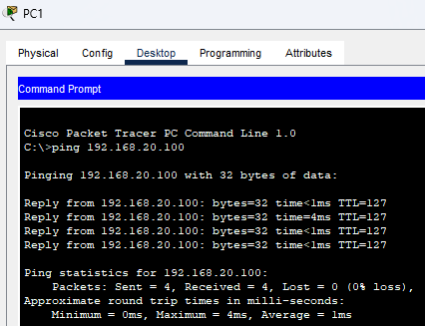

Test Command from Server (192.168.20.100) to PC0 (192.168.10.10) - telnet and ssh:

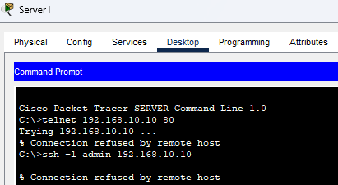

Q13. Try Static NAT, Dynamic NAT and PAT to translate Ips

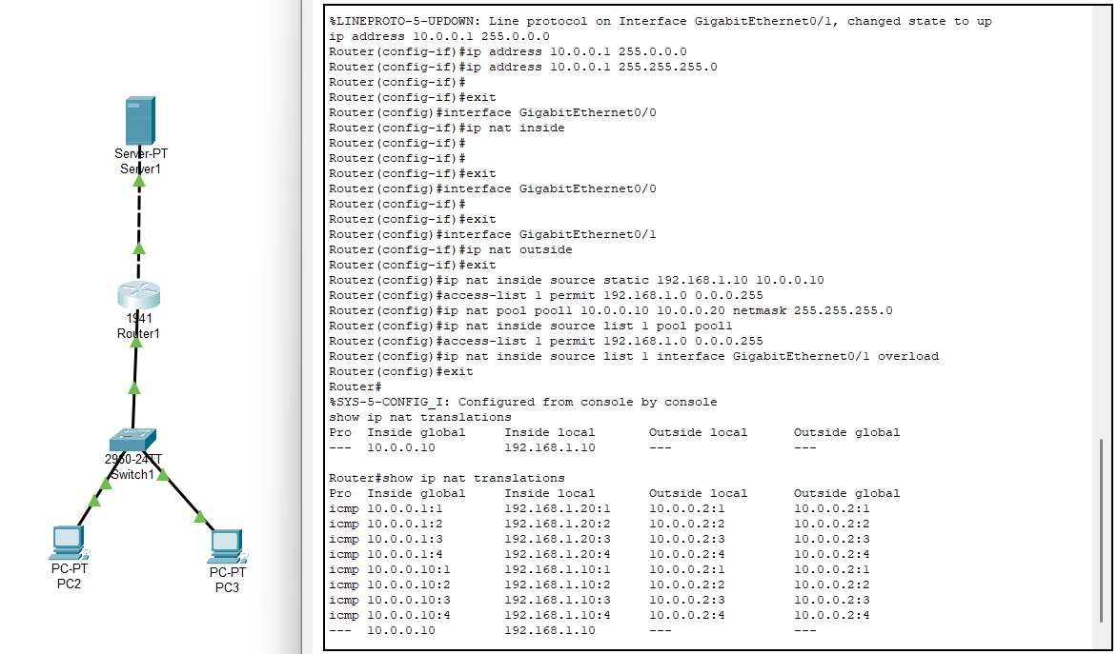

Q14. Download iPerf in laptop/phone and make sure they are in same network. Try different iPerf commands with tcp, udp, birectional, reverse, multicast, parallel options and analyze the bandwidth and rate of transmission, delay, jitter etc.

iPerf is a network testing tool used to measure bandwidth and performance. It operates in a client-server model, supporting TCP, UDP, multicast, and reverse testing. It measures throughput, latency, jitter, and packet loss.

- Basic Client-Server TCP Test
Command for Server: iperf3 -s
Explanation: The server listens for incoming connections and measures the performance.
Command for Client: iperf3 -c
Explanation: The client connects to the server and sends TCP traffic to measure throughput.

- UDP Test
Command for Server: iperf3 -s
Explanation: The server listens for UDP traffic.
Command for Client: iperf3 -c -u -b 100M
Explanation: The client sends UDP traffic to the server with a bandwidth of 100 Mbps. -u specifies UDP mode, and -b sets the bandwidth.

- Test with Specific Port
Command for Server: iperf3 -s -p 12345
Explanation: The server listens on port 12345.
Command for Client: iperf3 -c -p 12345
Explanation: The client connects to the server on port 12345.

- Reverse Mode Test
Command for Server: iperf3 -s
Explanation: The server listens for incoming connections.
Command for Client: iperf3 -c -R
Explanation: The -R flag reverses the data flow, meaning the server sends data to the client instead of the client sending data to the server. Useful for testing server upload capacity.

- Bidirectional (Duplex) Test
Command for Server: iperf3 -s
Explanation: The server listens for connections.
Command for Client: iperf3 -c -d
Explanation: The -d flag enables bidirectional testing, where data flows in both directions simultaneously. Measures throughput in both directions (client-to-server and server-to-client).

